Ficha Evaluación adulto mayor

Nombre: __________________________________ Edad:_______

Fecha:____________________

Test | Resultados
Sentadilla | Observaciones:
Chair Sit-&-Reach
Back Scratch
Functional reach
Chair Stand
Arm Curl
Time Up-&-Go
Time Up-&-Go Cognitivo
2-Min Step

Análisis
Sentadilla
- Feet Flatten
  - The arch of the foot will appear flat and pronate.
- Feet Turn Out
  - The client will squat with feet externally rotated.
- Heel of Foot Rises
  - The client’s body weight will shift forward and the heels will rise off of the floor.
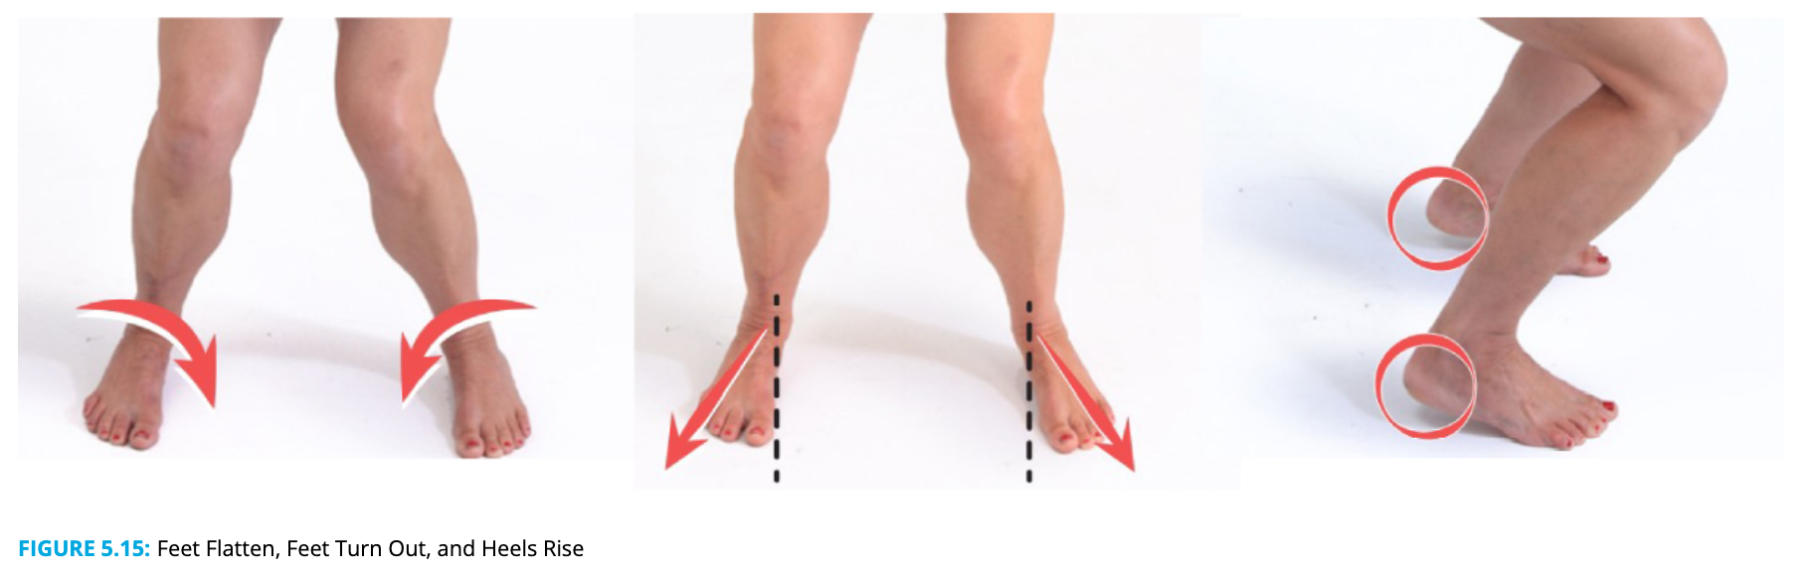

- ​​​​​​​Knees Move Inward
  - The knees will have a knock-kneed appearance where the knees converge and are not lined up over the second and third toes (Figure 5.16).​​​​​​​
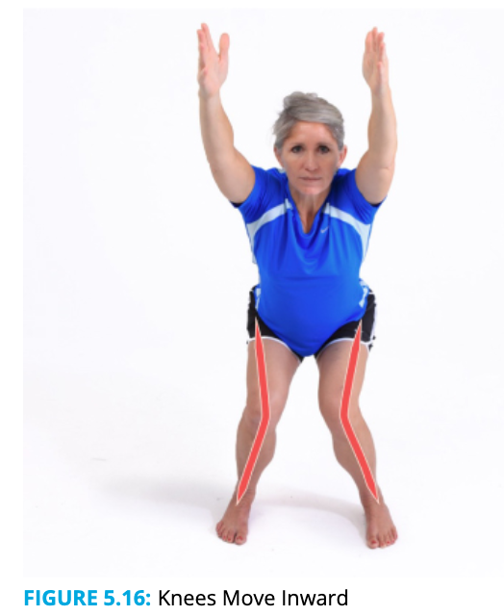
- ​​​​​​​Excessive Forward Lean
  - The trunk falls forward so the lower leg and trunk line are not parallel.
- Lower Back Arches
  - The low back will appear overly arched (extended).
- Lower Back Rounds
  - The lower back and buttocks will appear tucked under.
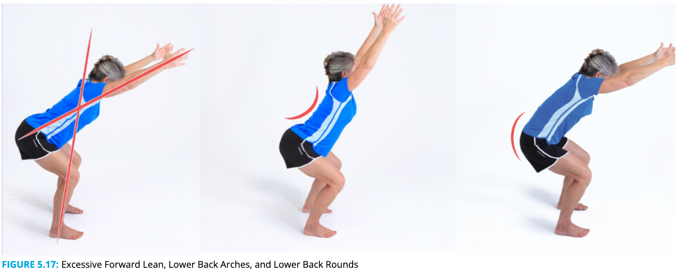
- Arms Fall Forward
  - The arms fall forward in front of the ears
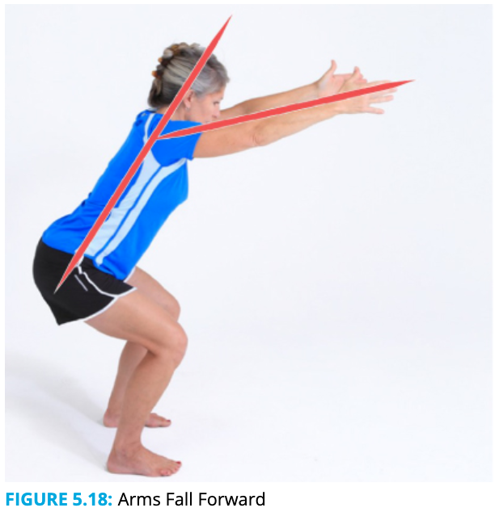

SFT Norms, Men
 | 60-64 | 65-69 | 70-74 | 75-79 | 80-84 | 85-89 | 90-94
Chair Sit-&-Reach (cm +/-) | -6.35– +10.16 | -7.62– +7.62 | -8.89– +6.35 | -10.16– +5.08 | -13.97– +3.81 | -13.97– +1.27 | -16.51– -1.27
Back Scratch (cm +/-) | -16.51– +0.0 | -19.05– -2.54 | -20.34– -2.54 | -22.86– -5.08 | -24.13– -5.08 | -25.4– -7.62 | -26.67– -10.16
Chair Stand (reps) | 14–19 | 12–18 | 12–17 | 11–17 | 10–15 | 8–14 | 7–12
Arm Curl (reps) | 16–22 | 15–21 | 14–21 | 13–19 | 13–19 | 11–17 | 10–14
Time Up-&-Go (segundos) | 5.6–3.8 | 5.7–4.3 | 6.4–4.2 | 7.2–4.6 | 7.6–5.2 | 8.9–5.3 | 10.0–6.2
Time Up-&-Go Cognitivo | +20% es malo
2-MIn Step (pasos) | 87–115 | 86–116 | 80–110 | 73–109 | 71–103 | 59–91 | 52–86

SFT Norms, Women
 | 60-64 | 65-69 | 70-74 | 75-79 | 80-84 | 85-89 | 90-94
Chair Sit-&-Reach (cm +/-) | -1.27– +12.7 | -1.27– +11.43 | -2.54– +10.16 | -3.81– +8.89 | -5.08– +7.62 | -6.35– +6.35 | -11.43– +2.54
Back Scratch (cm +/-) | -7.62 – +3.81 | -8.89– +3.81 | -10.16– +2.54 | -12.7– +1.27 | -13.97– +0.0 | -17.78– -1.27 | -20.32– -2.54
Chair Stand (reps) | 12–17 | 11–16 | 10–15 | 10–15 | 9–14 | 8–13 | 4–11
Arm Curl (reps) | 13–19 | 12–18 | 12–17 | 11–17 | 10–16 | 10–15 | 8–13
Time Up-&-Go (segundos) | 6.0–4.4 | 6.4–4.8 | 7.1–4.9 | 7.4–5.2 | 8.7–5.7 | 9.6–6.2 | 11.5–7.
Time Up-&-Go Cognitivo | +20% es malo
2-MIn Step (pasos) | 75–107 | 73–107 | 68–101 | 68–100 | 60–91 | 55–85 | 44–72

